**EAST WEST UNIVERSITY**

**LAB – 4**

**Newton’s Optimization Method**

**Course Code: ICE470**

**Course Title: Applied Numerical Methods**

**Section – 01**

**Submitted To:**

Muhammad Suhail Najeeb  
Lecturer

Dept. of ECE

East West University

**Submitted By:**

MD Imran Ahmed

ID: 2015-2-50-018

**Date of Submission**: 1-07-2019

**Objective**: Use Newton’s Method to find the maximum of

F(x) = 4x – 1.8x2 + 1.2x3 – 0.3x4

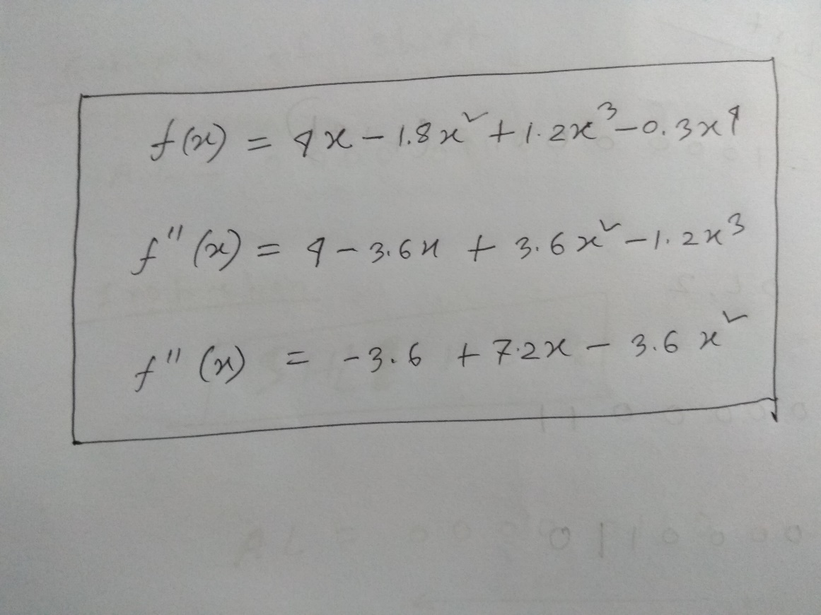

**Code**:

f = @(x) 4*x - 1.8*x^2 +1.2*x^3 - 0.3 * x^4;

df = @(x) 4 - 3.6*x +3.6*x^2 - 1.2*x^3;

ddf = @(x) -3.6 +7.2*x - 3.6*x^2;

x = 2.5;

iter = 0;

imax = 25;

es = 0.000001;

DF = 10000;

fprintf('iter \t x\t\t F \t\t\t\t DF \t\t DDF \n');

while(abs(DF) > es && iter < imax)

F = feval(f,x);

DF = feval(df,x);

DDF = feval(ddf,x);

x = x - DF/DDF;

iter = iter+1;

fprintf('%d \t %f \t %f \t %f \t %f \n', iter,x,F,DF,DDF);

end

**Output**:

Newtons_optimization_method

iter x F DF DDF   
1 2.345679 5.781250 -1.250000 -8.100000   
2 2.326629 5.884146 -0.124191 -6.519067   
3 2.326352 5.885340 -0.001750 -6.335797   
4 2.326352 5.885340 -0.000000 -6.333159

**Discussion**:

Here the maximum point of the f(x) were looked for. The first derivative of the f(x) function gave us the slope of that function and the second derivative gave the direction to that slope to move. Here the value of the second derivative was negative, so it clearly indicated that the next move should go upward. That is to the maximum point.